Project Title: Emerging Methods for early detection of forest fires Project Design Phase-I - Solution Fit Template Team ID: PNT2022TMID44251
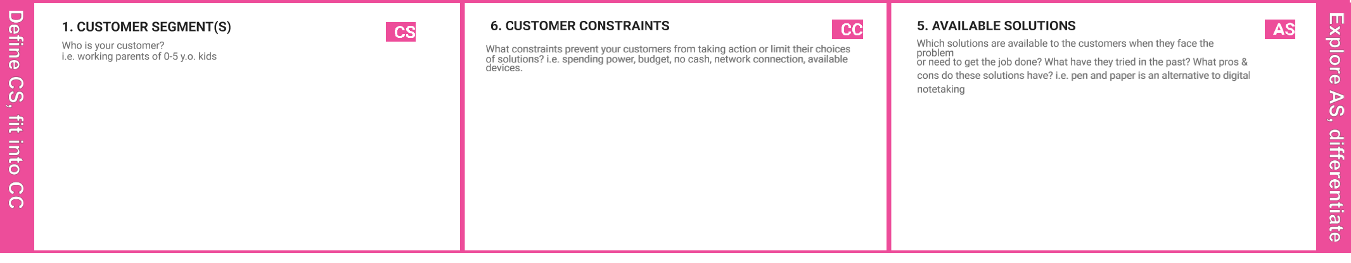

The forest resources which plays a vital role in sustaining lives on the earth, therefore to preserve them from unexpected outbreak of fire and smoke. The forest management team do need this device in fire prone areas.
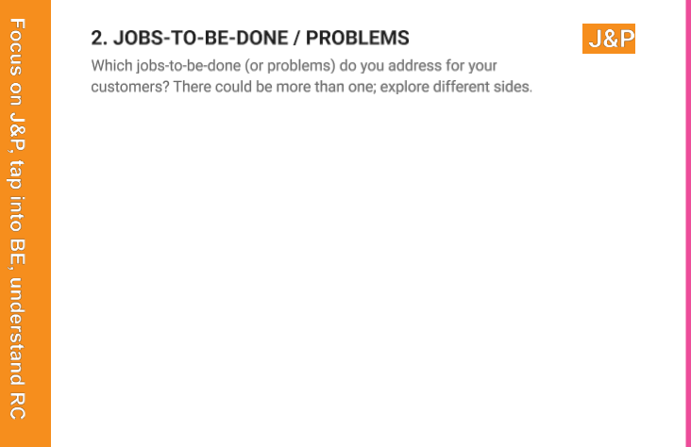

Climatic changes and the greenhouses gases are the reasons behind the destruction. Along with this the human factor to greedily use resources also play a vital reason for the forest fires.



Existing systems uses optical sensors for detecting forest fires. As fire is detected the sensors sends signal to the office of forest management. Among with that satellites are used to detect IR rays spotted in forest lands.
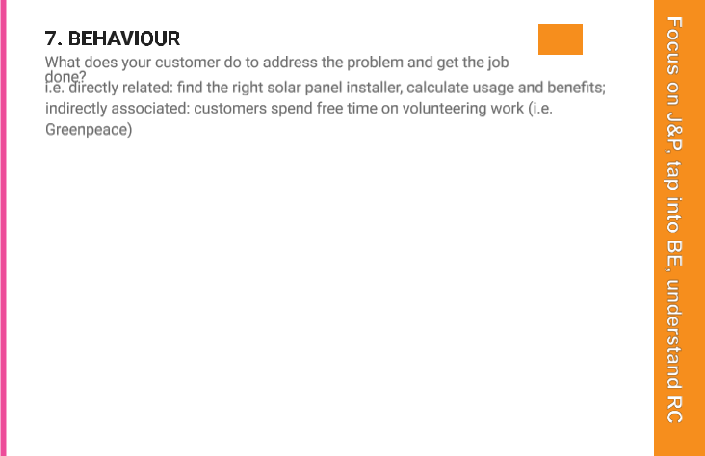

The main problem that exists is weather and climate by releasing large number of carbon dioxide, carbon monoxide and fine particulate matter into the atmosphere.

Resulting, air pollution can cause varying range of health issues, including respiratory and cardiovascular problems.

The reasons possible are:
1. Due to natural causes- Lightning
2. Man-made causes- Naked flame, cigarette, electric spark

Thus, continous care and monitoring is needed to preserve natural resources to save lives.

When fire is detected the sytem which is implemented to monitor the forests sets the alarm to ring, that is

it gives the signal through which fire management team and the forest committee tries to call off the fire. Thus, the aim is to recognise the fire as early as possible to prevent spread of fire which will cause further damage and it'll become difficult to control.

 | 3. TRIGGERS | TR |  |  | 10. YOUR SOLUTION | SL |  | 8. CHANNELS of BEHAVIOUR | CH
 | What triggers customers to act? i.e. seeing their neighbour installing solar |  |  |  | If you are working on an existing business, write down your current solution first, fill in |  |  | ONLINE
 | panels, reading about a more efficient solution in the news. |  |  |  | the canvas, and check how much it fits reality. |  |  | What kind of actions do customers take online? Extract online channels from #7
 | The unconsious behaviour towards burned cigarette left, |  |  |  | If you are working on a new business proposition, then keep it blank until you fill in the |  |  | Type your text
 |  |  |  |  | canvas and come up with a solution that fits within customer limitations, solves a problem |  |  | OFFLINE
 | chances of leaving the campfire remained burnt and it |  |  |  | and matches customer behaviour. |  |  | What kind of actions do customers take offline? Extract offline channels from #7 and use
 | can cause spread due to presence of vast dry grass |  |  |  | To minimize these loses, we have proposed a solution |  |  | them for customer development.
 | spread across and electric supply being disrupted.
 | spread across and electric supply being disrupted. |  |  |  | to detect early detection of forest fires by using
 |  |  |  |  | CCTV camera surveillance, which can detect fire in |  |  | Online Detection: Thus the chatbot or the API can
 | 4. EMOTIONS: BEFORE / AFTER | EM
 | 4. EMOTIONS: BEFORE / AFTER |  |  |  | indoor and outdoor activities. Thus instant alerts has |  |  | connect through internet to feed you with the
 | How do customers feel when they face a problem or a job and afterwards? |  |  |  |  |  |  | connect through internet to feed you with the
 |  |  |  |  | to be sent to the forest management office so that they |  |  | current status of the forest.
 | i.e. lost, insecure > confident, in control - use it in your communication strategy & design. |  |  |  |  |  |  | current status of the forest.
 |  |  |  |  | can take further actions to disrupt the daamge caused
 | Wildfires can cause lot of stress since the factor that |  |  |  | by the fire. |  |  | Offline Detection: Thus, the forest management can
 | influence their direction and intensity are unpredictable |  |  |  |  |  |  | send notice to the nearby residential areas or the
 | and can change at anytime. People who have lived |  |  |  |  |  |  | media can bring the awareness through news,
 | through wildfires can face dramatic mood swings, |  |  |  |  |  |  | radio.
 | anxiety and mood-swings.

